MASKS &
RHYTHMS

KENNETH A. MELÉNDEZ
HC/4 Box 23349 La Plata
Lajas, P.R. 00667
Cell: 787-448-6890
E-MAIL
MELENDEZ1969@AOL.COM)

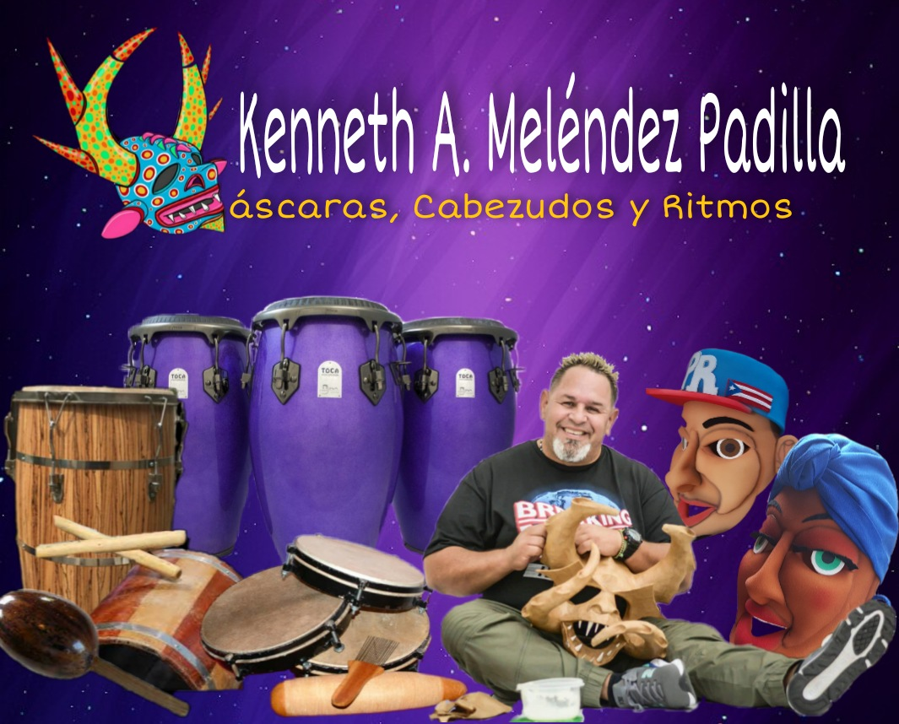

AutoBio Kenneth A. Meléndez
Kenneth A. Meléndez´s musical career began in the late 70’s. By the age of ten, he was playing and performing in public. Even though Kenneth was a self-taught musician on the congas at an early age, his formal musical training began at the School of Fine Arts in Ponce, Puerto Rico. Today, a multi-percussionist, he specializes in the following: Afro-Puerto Rican Folkloric Percussion, Barriles de Bomba, Panderos de Plena, Afro-Cuban Popular and Folkloric Percussion Tumbadoras, Bongo, Timbal, Bata, Chekere, Cajones de Rumba, and minor percussion. He also performs Afro-Dominican Popular and Folkloric Percussion, Tambora, Guira, Brazilian Zurdos, and Pandeiro. After his Puerto Rican upbringing on the island, he moved to Lorain, Ohio where he continued to play in local bands, which led to performing throughout the United States with various musical groups. Kenneth completed high school in Southview South Lorain 1988 and continued onto college, majoring in graphic design.
In 1990 Kenneth returned to Puerto Rico, where he became, and still is, very active in the music and art scene. He recorded with major Salsa bands and folkloric groups from Puerto Rico, and he collaborated with groups that received Grammy nominations for their recordings. In 2006, he endorsed “Remo” Percussion Company and Cases FV and now a Toca instruments Artist. He has played with various Latin groups such as, La Terrifica, Conjunto la Perla, Plena y Bembe, Los Pleneros del Barrio, los pleneros de Ponce, Los Calvos Jazz band, Roberto Ocasio Jazz band, Pedrito Guzman’s Jibarro Jazz, Orquesta La Solucion, Restauración Cultural, Monty y el truko de seis, secreto a voces and is now playing for , Costa brava (a successful Puerto Rican salsa band that has been in the industry for the past 37 years), and La Familia Sanabria (a renown folk music group from Puerto Rico, where Kenneth has been an important member for the past 15 years). This last music group performs 10-to-20 gigs a month and more than 50 festival and event performances per season. In terms of national and international stages, Kenneth Melendez has shared the stage with major national artists, such as Plenarium, Tommy Olivencia, Gilberto Santa Rosa, Victor Manuel, Andres Jiménes, Joseph Fonseca, Eddie Palmieri, Samuel Hérnandez, Plena Libre, Olga Tañon, Grupo Mania, Kao’s, Andy Montanéz, El Gran Combo, Sonora Ponceña, among others.
As an artist, Kenneth enjoys creating traditional masks with diverse materials, such as: burlap, coconut, wood, royal palm, paper Mache, gourd, foam, plastic, and wire mesh. He has exhibited his artworks in the following venues: McDonough Museum of Art in Youngstown, Ohio; Esqueleto Gallery in Oberlin, Ohio; Lorain County Community College Gallery, Lorain, Ohio; Jazz Gallery, San Francisco, California; American History Museum, Smithsonian Institute, Washington, D.C.; Museum of Puerto Rican Culture, San Juan, Puerto Rico; Museum of Art, Ponce, Puerto Rico; etc.
While maintaining a heavy performing schedule, Kenneth teaches and strenuously promotes knowledge of art, and Latin music, sharing his talents and experiences with schools, organizations, universities, and community programs.
His emphasis is especially directed towards art and music. Currently, Kenneth is teaching kids, teens and adults the importance of their Puerto Rican cultural traditions through the arts. When Kenneth is not playing or touring with salsa bands, he travels the United States, Europe, and the Caribbean with his Masks and Rhythms workshops.

PRESENTATIONS, WORKSHOPS, AND EXHIBITS

2023
- Mask and Rhythms work shop PRAA Chicago Il School
• Representative of Puerto Rico at New Orleans Heritage jazz fest
• Mask workshop el centro de servicio
Summer camp Lorain Ohio
• Mask workshop for gran winner Nabeska Aviles Cleveland Ohio
• Cultural exchange Dominican republic
2022
- Conjunto Chaney music tour pereira, bogotá, medellin, Colombia
• Artist recognition at Nacional E internacional Museum of traditional cardboard sculptures of México
- Artist recognition Somos Puerto Rico Telemundo Puerto Rico
- Mask and Rhythms work shop PRAA Chicago Il Schools
2021
- Mask & Rhythm worksshops PRAA for Chicago Schools.
- Artist recognition at Nacional E internacional Museum of traditional cardboard sculptures of México
- Mask and Craft Foam head charecters online workshops at Museum of Art of Ponce
- Program host of hablemos un poco de la percusión Radio tlamatine Amat México
- Mask and Rhythms online work shop PRAA Chicago Schools
- Grant nominee Catapult Caribeean Arts Grant, Jamaica
- Music instrument making online workshop Amistad Summer Camp Cleveland Ohio
2020
• Mask Making workshop Amistad summer Camp Cleveland Ohio
• NAMM Toca convention booth Anaheim California
2019
- Mask make for miss Grand international representative of Puerto Rico
- Mask workshop at Central high school Saint Croix
- Mask workshop and expo at Caribbean museum of art in Saint Croix
- Mask and Rhythm workshop Latino Cultural Center Dallas Texas
- Mask and Rhythm whokshop Cayahoga arts & culture, Cleveland
- Music concert Conjunto Chaney Dia nacional de la salsa San Juan, Puerto Rico
- Conjunto Chaney’s 40th anniversary. Music tour Panama, South America
- Mask exhibition Enmascararse Manati Puerto Rico
- Mask and large head foam characters Ponce, San German, Mayagüez, San Juan Instituto de Cultura Puertorriqueña
2018
- Masks Workshop; Hispanic Heritage L.C.C.C Elyria, Ohio
- Masks and Rhythms Workshops; Ohio Arts Council, Lorain, Ohio
- Conjunto Chaney 40th anniversary. Music tour various cities Colombia, South America
- Mask creator for Mister Global International, Puerto Rico
- Masks collective mysteries of the six, Galeria Betances Mayagües, Puerto Rico
- Conjunto Chaney (40 aniv.), Music tour, Miami, U.S.A.
-music recording 40 años Conjunto Chaney, Rolos Studio,
Guaynabo P.R.
2017
- Masks and Rhythms Workshops; Ohio Arts Council, Lorain, Ohio
- Master Masks and Rhythms Workshop; Festival Julia de Burgos, Cleveland, Ohio
- Conjunto Chaney Music tour; Cali, Colombia, South America
- Conjunto Chaney Music tour; Costa Rica, South America
- Mexican tour: Cultural Exchange; Vera Cruz, Zacatecas, Mexico
2016
- Masks and Rhythms Workshops for schools in Aguada, P.R.
- Music tour: Orq. Costa Brava; Lima, Peru
- Conjunto Chaney Music tour, New Jersey, U.S.A.
- Music tour: Conjunto Chaney Friendship VIPR; Saint Croix, VI
2015
- Conjunto Chaney Music; Bogota Colombia, South America
- Workshops on Masks and Bigheads; Sabana Grande, P.R.
- Workshops on Masks and Bigheads; Guanica, P.R
- Masks and Bigheads Workshops; PRAA Chicago Schools, IL
- Restauracion Cultural Bomba Rhythms Workshop, PRAA Chicago Schools, IL
2014
- Masks and Bigheads Workshops; PRAA Chicago Schools, IL
- Workshops on Masks and Bigheads; Baobab Cultural Center, Rochester, N.Y.
- Conjunto Chaney Music tour; New York, U.S.A.
- Workshops on Masks and Big Heads; Conversatorio Carolina, P.R
- Masks and Rhythms Workshop; Lajas, P.R
- Workshops on Masks and Big Heads; Hormigueros, P.R
- Grand Marshall Carnival; Ponce, P.R
- Conjunto Chaney 40 aniv. Music tour. Orlando, FL U.S.A.
2013
- Music tour cultural exchange; Martinique Island
- Mask maker for the traditional costume for Mr. Mundo representative of Puerto Rico
- Masks & Rhythms workshops; PRAA Chicago Schools ,IL
2012
- Masks, Puppets & Rhythms workshop; CityFolk Fest. Dayton, Ohio
- Music tour cultural exchange; Guadaloupe island
- Music recording: Orq. La Solucion; Cabo Rojo Studio, P.R.
- Music tour cultural exchange; various cities in Italy, Europe
2011
- Mask maker for the traditional costume for the Miss Universe representative of Puerto Rico
- Artisans’ RECOGNITION Carnaval Ponceño, Ponce, Puerto Rico
- Masks & Rhythms workshops for youths with disabilities and juvenile institutional programs; Arte para sanar, Institute of Puerto Rican Culture, San Juan, Puerto Rico
2010
- Masks & Rhythms Workshops for youths with disabilities, Arte para sanar; Institute of Puerto Rican Culture; San Juan, Puerto Rico
- Masks & Rhythms Workshop; Esperanza and Julia de Burgos organizations, Cleveland, Ohio
- Masks & Rhythms Workshop; El Centro de Servicio Social, Lorain, Ohio
- Masks, Puppets & Rhythms Workshop; CityFolk Fest.; Dayton, Ohio
2009
- Masks & Rhythms Workshops; Juvenile Institutional Programs, Arte para sanar, Institute of Puerto Rican Culture; San Juan, Puerto Rico
- Masks & Rhythms Workshops; Expres-arte, Institute of Puerto Rican Culture; San Juan, Puerto Rico
- Remo Rhythm Workshop; Percussion Paradise Ranch, Valencia California
- Music recording Esencia, P&B Music Studio; Villalba, Puerto Rico
- Masks & Rhythms Workshop; El Centro de Servicio Social, Lorain, Ohio
- Masks & Rhythms Workshop; CityFolk Fest. Dayton, Ohio
- Carnival masks exhibit: Plaza Del Caribe; Ponce, Puerto Rico
- Masks exhibit “Carnaval Ponceño” Castillo Seralles; Ponce, Puerto Rico
- Masks & Rhythms Workshops; Arte para sanar; Institute of Puerto Rican Culture; San Juan, Puerto Rico
2008
- Masks & Rhythms Workshops: drug addiction programs, Arte para Sanar; Institute of Puerto Rican Culture; San Juan, Puerto Rico
- Percussion workshop at pure sound music store
- Bomba Rhythm Workshop; Ponce, P.R
- Remo Percussion workshop at Willie Rosario Fine Art School; Coamo P.R.
- Masks & Rhythms Workshops: Expres-arte; Institute of Puerto Rican Culture; San Juan, Puerto Rico
- Remo Clinic workshop & Art Show; CityFolk Fest. Dayton, Ohio
2007
- Masks & Rhythms workshops for H.I.V programs, Arte para sanar Institute of Puerto Rican Culture; San Juan, Puerto Rico
- Masks & Rhythms workshops; Expres-arte. Institute of Puerto Rican Culture; San Juan, Puerto Rico
- Masks & Rhythms Workshops Aspira Chicago,IL
- Music presentation Heineken jazz fest. Anfiteatro Tito Puente, San Juan, P.R.
- Masks & Rhythms Workshops El Centro de Servicio Social, Lorain Ohio
- Masks workshop; Music in the Air; Columbus, OHIO
- Masks Workshops: CityFolk Fest. Dayton, Ohio
2006
- Masks & Rhythms Workshops; Expres-arte; Institute of Puerto Rican Culture; San Juan, Puerto Rico
- Masks Workshops; Music In The Air. Columbus, Ohio
- Rhythms workshop for the Roberto Ocasio Foundation; Summer Music Camp. Cleveland, Ohio
- Masks & Rhythms workshops. CityFolk Fest. Dayton, Ohio
- Signed with Remo Percussion Instruments, USA
- CD recording with Familia Sanabria: Vientos de Trova y Plena; P&B Music Studio. Villalba, Puerto Rico
- Music presentation: Ibero Americano Games. Ponce, Puerto Rico
- Music presentation: Limite 21; Roberto Clemente, San Juan, Puerto Rico
- Masks & Rhythms Workshops. Antonia Pantojas School, Chicago, IL
- Masks Workshops Latino Fest. Wisconsin, Milwaukee
2005
- Masks & Rhythms Workshops; Expres-arte. Institute of Puerto Rican Culture. San Juan, Puerto Rico
- Music Recording: Junito y Secretos a Voces. Sensoround Studio Mayaguez, Puerto Rico
- Masks Workshops. Music In The Air. Columbus, Ohio
- Masks Workshops. Latino Fest. Toledo, Ohio
- Masks & Rhythms workshops; Antonia Pantojas School, Chicago
- Masks Workshops Latino Fest. Wisconsin, Milwaukee
- Music Recording: Compañia Jibara, P&B Music Villalba, Puerto Rico
- Masks & Rhythms workshops. Central High School ST.Croix, US Virgin Islands
2004
- Masks & Rhythms workshops. Cultural Exchange. Santiago, Dominican Republic
- Masks & Rhythms workshops. Expres-arte. Institute of Puerto Rican Culture. San Juan, Puerto Rico
- Masks Workshops. Music In The Air. Columbus, Ohio
- Masks Workshops. Latino Fest. Toledo, Ohio
- Masks & Rhythms workshops. Latino Fest. Lorain, Ohio
- Masks Workshops. Latino Fest. Wisconsin, Milwaukee
2003:
- Masks & Rhythms workshops Cultural Exchange Santiago, Dominican Republic
- Music Presentation: Felle y Amigos Las Tablas. Santiago, Dominican Republic
- Masks & Rhythms workshops Expres-arte. Institute of Puerto Rican Culture. San Juan, Puerto Rico
- Rhythms Presentation: Roberto Clemente School; Chicago, IL
- Carnival Masks exhibit: Casa Escuté. Carolina, Puerto Rico
- Expresarte Art Presentation: TV Program canal 6. San Juan, Puerto Rico
2002:
- Masks & Rhythms workshops. Expres-arte. Institute of Puerto Rican Culture. San Juan, Puerto Rico
- Masks & Rhythms from Puerto Rico Presentation. Fitur World Fair Madrid, Spain
- Masks & Rhythms workshops. Cultural Exchange. Santiago, Dominican Republic
- Artists Recognition: Casa Cultural, Dominican Republic
- Masks & Rhythms from Puerto Rico Presentation. ITB World Fair, Berlin, Germany
- Masks Workshops. Music In The Air. Columbus, Ohio
- Masks Workshops. Latino Fest., Toledo, Ohio
2001:
- Carnival Masks exhibit “El Rostro Oculto”. Ponce Museum, Ponce, Puerto Rico
- Art Presentation: TV Program “Desde Mi Pueblo” Canal 6. San Juan, Puerto Rico
- Masks & Rhythms workshops. Central High School. ST.Croix, USVI
- Masks exhibit “carnaval” Centro Indígena de Tibes. Ponce, Puerto Rico
2000:
- Folk Music workshops at major schools in Puerto Rico. Expres-arte. Institute of Puerto Rican Culture. San Juan, Puerto Rico
- Masks Workshops. Ohio Latino Arts Council. Columbus, Ohio
Rhythms workshop. Ohio Latino Arts Council. Columbus, Ohio
- Masks & Rhythms workshops. Music In The Air. Columbus, Ohio
- Rhythms workshop. Fire House. Columbus, Ohio
1999:
- Artistic Presentation: Jossie y Nuestra Gente. Puerto Rican Day Parade. Manhattan, New York
- Masks exhibit “Espiritus Del Pasado”. Fine Arts Center. Guayama, Puerto Rico
- Music Presentation. World Folk Music Fest. Palmas de Mallorca, Spain
- Carnival Mask Exhibit & Book Presentation: Plaza Del Caribe Ponce, Puerto Rico
- Masks exhibit “Espiritus Del Pasado”. Cultural Center. Ponce, Puerto Rico
- Art exhibit “Ohio Latino Art”. Lorain County Community College; Lorain, Ohio
- Masks & Rhythms workshops. Central High School. ST.Croix, US Virgin Islands
- Art Props & Music Composition for Movie “Under Suspicion” recorded in San Juan, Puerto Rico
1998:
- Masks & Rhythms Presentation: “Holiday Celebrations”. Smithsonian National Museum of American History; Washington, D.C.
- Magazine Presentation: “Mascaras”. Institute of Puerto Rican Culture. San Juan, Puerto Rico
- Masks Workshops. Ohio Latino Arts Association. Toledo, Ohio
- Masks exhibit: “Traditonal Masks from Puerto Rico”. Institute of Puerto Rican Culture. San Juan, Puerto Rico
- Artist’s Recognition: Institute of Puerto Rican Culture. San Juan, Puerto Rico
- Masks & Rhythms workshops. Bronx High Schools. Bronx, New York
- Artistic Presentation: Puerto Rican Day Parade. Manhattan, New York
- Art exhibit: “Mascaras y Atuendos”. Castillo Seralles. Ponce, Puerto Rico
- Masks exhibit “Herencia Carnavalescas”. Centro Indígena de Tibes Ponce, Puerto Rico
- Music Presentation: Don Francisco TV Show, Univision, USA
1997:
- Music Presentation: World Folk Music Fest. Palmas de Mallorca, Spain
- Masks Workshops for Video American Culture for Children Puerto Rican Heritage, Schlessinger Video Production, USA
- Art exhibit: “Multi-Culture Treads”. Lorain County Community College, Lorain, Ohio
- Mask exhibit: “Carnaval Ponceño”. Castillo Seralles. Ponce, Puerto Rico
- Masks & Rhythms workshops. Columbia University. Manhattan, New York
- Artistic Presentation: Puerto Rican Day Parade. Manhattan, New York
1996:
- Masks & Rhythms workshops for Historical Resources of Puerto Rico. Lorain Ohio
- Masks & Rhythms workshops. Lincoln Elementary School; Lorain, Ohio
1995:
- Masks exhibit in Castillo Seralles Museum. Ponce, Puerto Rico
1994:
- Masks exhibit & Music Presentation: McDonough Museum of Art. Youngstown, Ohio
- Masks & Rhythms workshops. Youngstown University. Youngstown, Ohio
1993:
- Masks exhibit: “Masks Traditions” Esqueleto Gallery. Oberlin, Ohio

