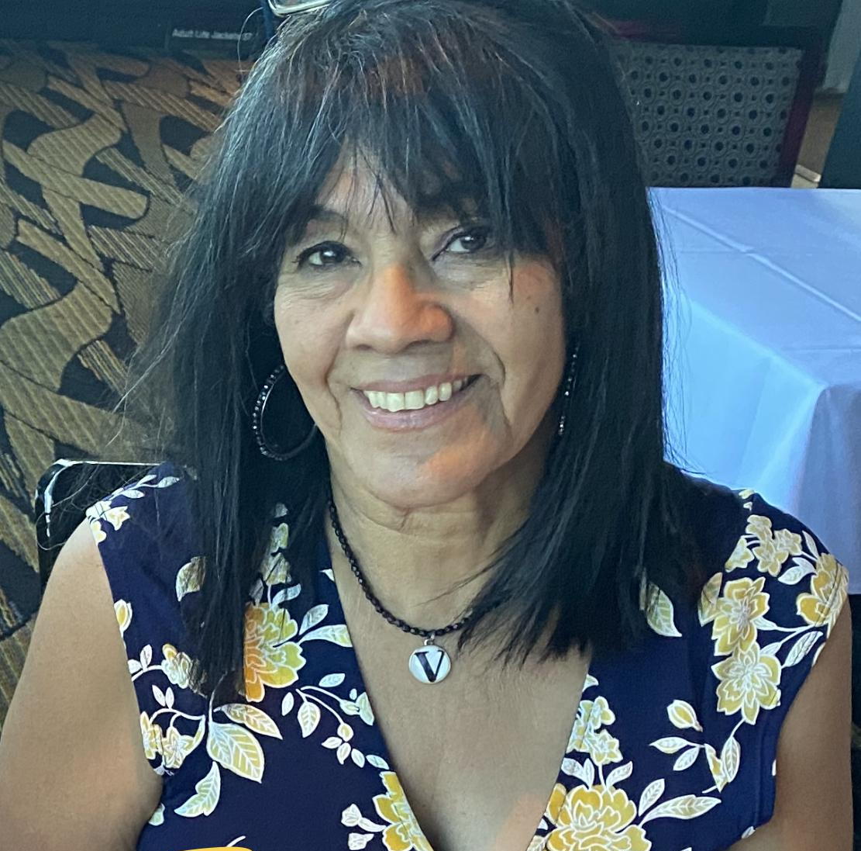
MI MADRE/MY MOTHER

Who is my mother? My mother is VIVIAN COLLAZO CRUZ, born in Ponce, Puerto Rico in December in the late 1940s; born the fourth child, but the FIRST DAUGHTER of what would be 11 siblings, this positioning would become important in her later years.

My mother would be sent to New York in her early teen years and begin working while living with her aunts, who were also her contemporaries. Soon she would meet my father. Her aunts were dating and marrying a set of cousins and my father would come to visit shortly after leaving the Army, see her, and marry her six months later.

My parents continued working, my mom as a seamstress, my dad as an owner of a bodega. A month shy of their one year anniversary, I came along. This would be a pivotal moment in their marriage and decisions had to be made. My parents knew that The Bronx was not a place to raise their family, so they made a few calls, packed their bags and drove across the country to land in Englewood, Chicago. We arrived in Chicago at the end of the 60s and by 1971, I would have two baby brothers.

My parents would sacrifice and on my eighth birthday would purchase their first home. When my youngest brother entered kindergarten, my parents would make another pivotal decision - one would stay home while the other would continue to work. After much deliberation, they decided that Mami would stay home and Papi would continue to work. Mami would then be at our school to check in on us, completely care for the home and fully dive into homework and everything that had to do with her children. How Mami could help us with our homework, when she didn’t know the language, is still a mystery to me. I cannot remember when she crossed the threshold from being monolingual Spanish speaking to bilingual Spanish and English speaking. She fixed everything that broke down in the house, she taught us the language and culture of our island. Mami was a force to be reckoned with, she taught us how to be focused and determined yet humble and kind. She never gave up her role as co-parent and co-disciplinarian, my parents were ALWAYS on the same page when it came to the children.

As my parents drove into us the importance of education, they would demonstrate by both obtaining their GEDs. Today, it’s not our degrees that are on the wall, that was expected. It is our high school diplomas, along with their GED diplomas that are on the wall. I will never forget how they were examples for our future choices.

When my mother’s family moved to Chicago when I was around 10-11 years old, I would also have the wisdom of my little, yet powerful, Abuelita Mercedes. I watched how my mother continued to learn from her and in my grandmother’s final years, my mother would be the main sibling who would care for her until she took her last breath. My mother was never one to handle death easily, but I watched as she championed and cared for her parents. She made a daily trip across the city… about a 30 -40 mile round trip to take care of them. Upon their respective passings, Mami would also become the matriarch of the entire Collazo family. My mom once said to me, that if she had a do over in her life, she would endure the same heartaches and challenges to have the same three children. Always knowing that we were the focus of her life, that we were her legacy, made it easy for each of us to always ask the question, “will this choice hurt or bring pride to our mother?”. We were not perfect, we made many of the same mistakes others made in their lives; we didn’t always agree with our parents' decisions or ideas, but the essence of humanity, of parenting, of living in this world, has always been central to us… and that came from our mother.

The Cruz children, Victor, Rolando and I were and are still blessed to have been raised with both parents in our home; but we all know that it is the mother who instills understanding of culture and language in a home… That is our mother, VIVIAN COLLAZO (de) Cruz. A strong, loving and unwavering Puerto Rican mother. Bendicion Mami.

